Ideation Phase
Brainstorm & Idea Prioritization Template

Date | 31 January 2026
Team ID | LTVIP2026TMIDS66241
Project Name | Civil Engineering Insight Studio
Maximum Marks | 4 Marks

Brainstorm & Idea Prioritization:
Brainstorming provides a free and open environment that encourages everyone within a team to participate in the creative thinking process that leads to problem solving. Prioritizing volume over value, out-of-the-box ideas are welcome and built upon, and all participants are encouraged to collaborate, helping each other develop a rich amount of creative solutions.
Use this template in your own brainstorming sessions so your team can unleash their imagination and start shaping concepts even if you're not sitting in the same room. Step-1: Team Gathering, Collaboration and Select the Problem Statement
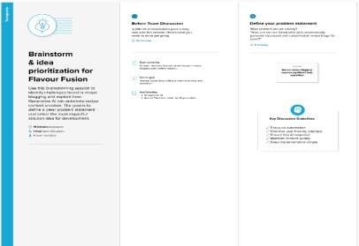

Step-2: Brainstorm, Idea Listing and Grouping
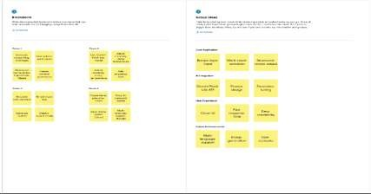

Step-3: Idea Prioritization
